**Objective:**

* Learn about Exeptions, Keywords and Convertions in JavaScript.

1. **Solve the following problems:**
2. Write a function called divide that takes two parameters: a numerator and a denominator.

Your function should return the result of numerator / denominator.

However, if denominator is zero you should throw the error, "Attempted to divide by zero." Use finally also.

1. You are performing a unit test on the following JavaScript code:

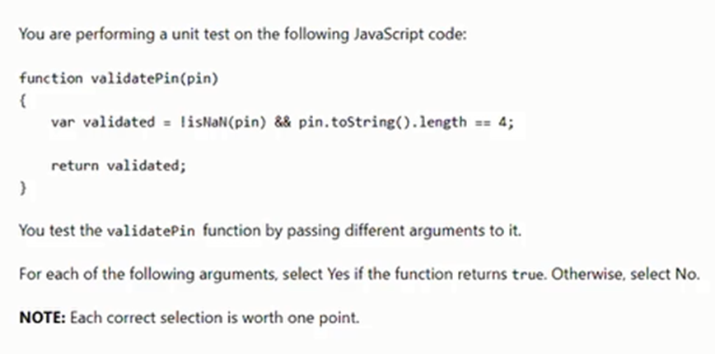

You test the validate in function by passing different arguments to it.

For each of the following arguments, select Yes if the function returns true. Otherwise, select No.

NOTE: Each correct selection is worth one point.

|  |  |  |
| --- | --- | --- |
| **Argument** | **True** | **False** |
| “ABCD” |  | **X** |
| “1234” | **X** |  |
| 1234 | **X** |  |
| 20 * 50 | **X** |  |

1. Write a JavaScript function to check whether a string is blank or not.

**Test Data:**

*console.log(is_Blank(''));*

*console.log(is_Blank('abc'));*

*true*

*false*

1. **Select true or false for each statement:**

|  |  |  |
| --- | --- | --- |
| **Statement** | **True** | **False** |
| 1. External JavaScript files can be cached. | **X** |  |
| 1. Internal JavaScript can be placed between the <head> tags. |  | **X** |
| 1. Placing your scripts at the bottom of the page body lets the browser load the other elements of the page first | **X** |  |
| 1. Internal JavaScript uses the tag <script src="internal" type="text/javascript">. |  | **X** |